

**Developer**: Eric Wallace

**Date**: November 19, 2021

# IT 145 Global Rain Summary Report Template

## Directions

Place your pseudocode, flowchart, and explanation in the following sections. Before you submit your report, remove all bracketed text.

## Pseudocode

When you are done implementing the Pet class, refer back to the Pet BAG Specification Document and select either the pet check in or check out method. These methods are detailed in the Functionality section of the specification document.

Write pseudocode that lays out a plan for the method you chose, ensuring that you organize each step in a logical manner. Remember, you will *not* be creating the actual code for the method. You do *not* have to write pseudocode for both methods. Your pseudocode must not exceed one page.

SET boolean existingPet = FALSE;

SET int numOfDays = 0;

START OF PROGRAM

USER chooses to start a new boarding by clicking a button NEW BOARDING

GET from an INPUT prompting user "Has pet been here before" AND TO SELECT (YES or NO) on dropdown

SET existingPet variable to value of dropdown

IF existingPet == YES THEN

GET petName from INPUT prompting user "Enter name of pet"

CALL setPetName()

GET pet details based on petName

OUTPUT pet details

USER can UPDATE pet information

ELSE

OUTPUT new pet FORM

GET FROM INPUTS prompting user for pet name, age and type

CALL FUNCTION Pet(petName, petAge, petType) to create a new pet

OUTPUT pet details

END IF

IF petType = Dog THEN

IF CALL getDogSpaces() < 30 THEN

CREATE new Dog for new dog to be boarded

CALL setDogSpaceNumber(dogSpaces + 1)

CALL setDogSpaces(dogSpaceNumber)

GET a integer from an INPUT prompting for the number of days for boarding

SET numOfDays variable to value of INPUT

CALL setDaysStay(numOfDays)

GET from an INPUT prompting user "Would owner like pet to be groomed?"

AND TO SELECT (YES or NO) on dropdown

IF SELECT value is YES THEN

IF getDaysStay() >= 2 THEN

CALL setGrooming(TRUE)

ELSE

OUTPUT petName "must stay 2 or more days for grooming"

CONTINUE

END IF

END IF

OUTPUT numOfDays

ELSE

OUTPUT "No dog spaces available"

RETURN to START

END IF

ELSE

IF CALL getCatSpaces() < 12 THEN

CREATE new Cat for new cat to be boarded

CALL setCatSpaceNumber(catSpaces + 1)

CALL setCatSpaces(catSpaceNumber)

GET a integer from an INPUT prompting for the number of days for boarding

SET numOfDays variable to value of INPUT

CALL setDaysStay(numOfDays)

OUTPUT numOfDays

ELSE

OUTPUT "No cat spaces available"

RETURN to START

END IF

END IF

END PROGRAM

## Flowchart

Based on the pseudocode you wrote, create a flowchart using a tool of your choice for the method you selected. In your flowchart, be sure to include start and end points and appropriate decision branching, and align the flowchart to the check in or check out process. Your flowchart must be confined to one page.

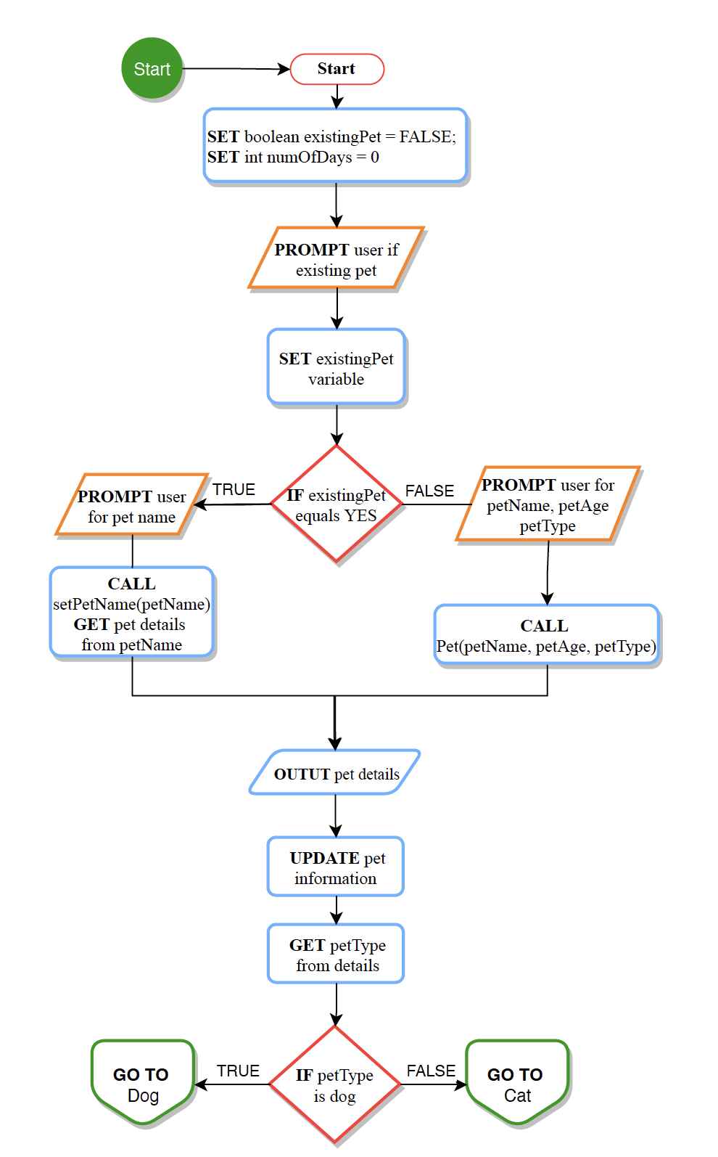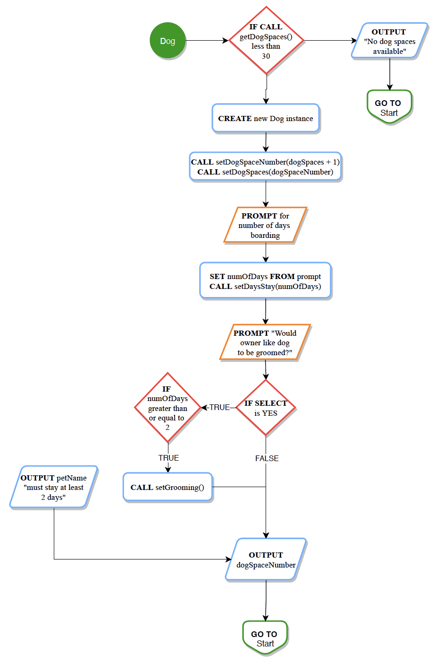

## OOP Principles

## Explanation

Briefly explain how you applied object-oriented programming principles and concepts (such as encapsulation, inheritance, and so on) in your software development work thus far. Your explanation should be one paragraph, or four to six sentences.

The dog and cat classes would extend the Pet class allowing the use of the pet methods and attributes, but encapsulation and abstraction the dog and cat classes can’t access or view the methods or attributes from one another. If the pet was new created a new instance of pet passing in the name, age and type. I could have used polymorphism to use the dog and cat classes to modify the pet class adding additional attributes to the Pet class.